1.Create a square matrix with random integer values(use randint()) and use appropriate functions to find:
i) inverse
ii) rank of matrix
iii) Determinant
iv) transform matrix into 1D array
v) eigen values and vectors

Program
import numpy as np
import numpy as nf
from numpy.linalg import eig
mat = np.random.randint(10, size=(3, 3))
array = nf.random.randint(10, size=(3, 3))
print(mat)

M_inverse = np.linalg.inv(mat)
print("inverse of the array")
print(M_inverse)

rank = np.linalg.matrix_rank(mat)
print("Rank of the given Matrix ")
print(rank)

det= np.linalg.det(mat)
print("determinant of the given Matrix ")
print(det)

arr=mat.flatten()
print("transform matrix to array ")
print(arr)

w,v=eig(array)
print('E-value:', w)
print('E-vector', v)

Output
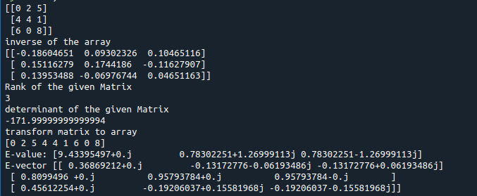
2.Create a matrix X with suitable rows and columns
i) Display the cube of each element of the matrix using different methods
(use multiply(), *, power(),**)
ii) Display identity matrix of the given square matrix.
iii) Display each element of the matrix to different powers.
iv) Create a matrix Y with same dimension as X and perform the operation X²+2Y

Program

import numpy as np
x=np.array([[2,3,4],[5,6,7],[8,9,10]])
print(x)
#i) Display the cube of each element of the matrix using different methods
#(use multiply(), *, power(),**)

print(np.power(x,3))
print(np.multiply(x,(x*x)))
print(x*x*x)
print(x**3)
#Display identity matrix of the given square matrix.
b=np.identity(3,dtype=int)
print(b)
#iii) Display each element of the matrix to different powers.
out=np.power(x,x)
print(out)

Output
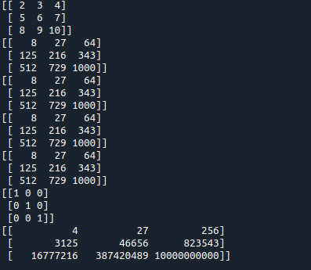

4.Given 3 Matrices A, B and C. Write a program to perform matrix multiplication of the 3 matrices.

Program

import numpy as np
m1 = np.array([[1,4],[2,5]])
m2 = np.array([[1,4],[2,5]])
m3 = np.dot(m1,m2)
print("multiplication of two matrix")
print(m3)
m4=np.array([[5,6],[1,4]])
m5=np.dot(m3,m4)
print("multiplication of two matrix with third one")
print(m5)

Output

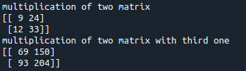

5.Write a program to check whether given matrix is symmetric or Skew Symmetric.

Program

import numpy as np

array= np.array([[2,3,4], [3,45,8], [4,8,78]])
print("The given matrix is \n", array)

# Transposing the Matrix
print('\n\nTranspose of the given matrix is \n', array.T)

if array.T.all() == array.all():
print("\nTranspose is eqaul to array and It is therefore symmetric\n")

else:
print("\nNot a symmetric matrix !!\n")

Output
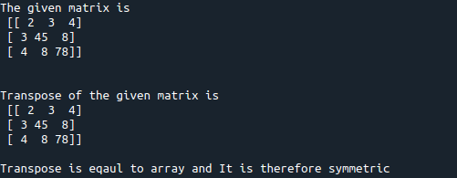

7.Write a program to perform the SVD of a given matrix. Also reconstruct the given matrix from the 3 matrices obtained after performing SVD.

Program

import numpy as np
from numpy import array
from scipy.linalg import svd
from numpy import dot
from numpy import diag
# define a matrix
A = array([[1, 2,1], [3, 4,2], [5, 6,4]])
print(A)
# SVD
U, s, VT = svd(A)
print(U)
print(s)
print(VT)
Sigma=diag(s)
B=U.dot(Sigma.dot(VT))
print(B)

Output

